Unit 2: Europe Study Guide

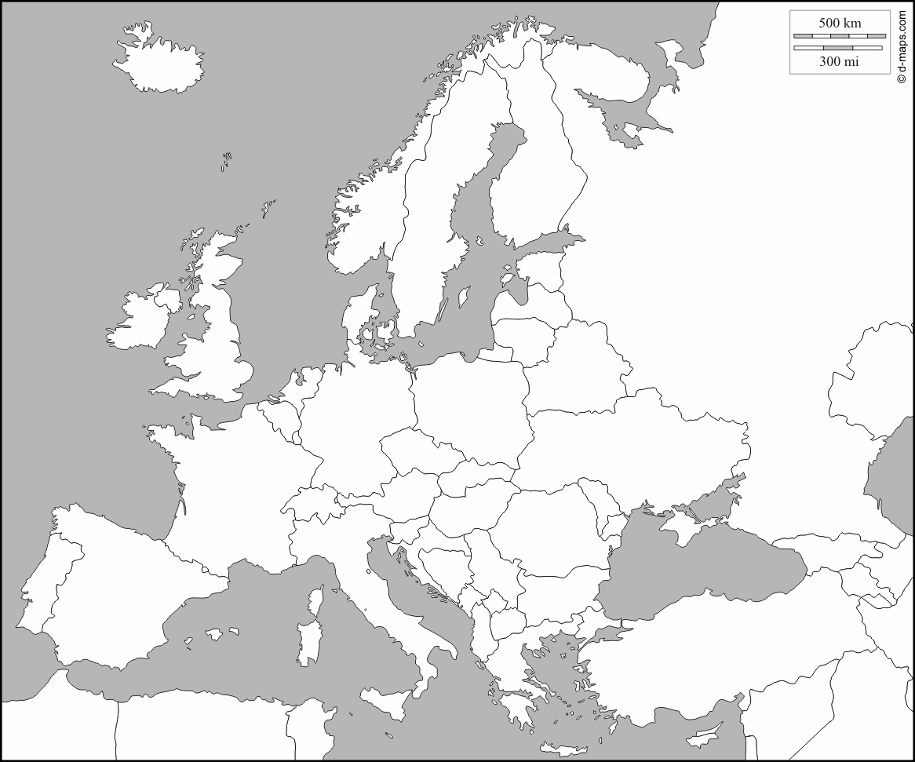 | Danube River, Rhine River, English Channel, Mediterranean Sea,  European Plain,  Alps,  Pyrenees,  Ural Mountains, Iberian Peninsula.  France,  Germany,  Italy,  Russia,  Spain,  Ukraine,  United Kingdom.
Write the term that is missing in the box at right. Two lines means two words.
1 | When pollution from cars and factories mixes with moisture in clouds, it falls as __ __. | Acid Rain
2 | A limit on the number of an imported good is called a __. | Quota
3 | The people have the power. My country is a __. | democracy
4 | Republic, parliamentary democracy, chancellor is chief executive. Welcome to __! | Germany
5 | The countryside of Europe is famously beautiful, but 75% of the people live in __. | Urban or cities
6 | Allah spoke the Koran to Muhammad. This religion is _____. | Islam
7 | The __ __ is the integration of the economies of 28 countries in Europe. | European  Union
8 | Within the EU, 19 countries use the same currency, called the __. | Euro
9 | I am a king, but I have no power. I represent our history and tradition. We have a __ __. | Constitutional monarchy
10 | Our chief executive is not a legislator. We have a __ __. | Presidential democracy
11 | I am the queen of a country where I have all the power. How nice! Welcome to my __ __. | Autocratic monarchy
12 | A tax or fine on an imported good is called a __. Its purpose is to raise the price of imports. | tariff
13 | The voters choose the legislators, then the legislators choose one of themselves to be the chief executive. We have a __ __. | Parliamentary democracy
14 | A general sense of the economic success or struggle of a country is called the __ of __. | Standard of living
15 | Italy, France, and Spain were conquered by the ancient Romans, so those three languages are called ____ _____. | Romance languages
16 | In 1986 a nuclear power plant in the town  of __ exploded and sent radioactive clouds over Europe. | Chernobyl, Ukraine
17 | This country is trying to leave the European Union: __ __ | United Kingdom
18 | The European Union is a free-trade zone, which means there are no __ __. | trade barriers
19 | The country ___ is so big, cold, and empty that it is hard for them to create economic value from the natural resources they have. | Russia
20 | The natural advantages of __ are numerous: rivers, mountains, ocean coast, farmland on the European Plain, central location in Europe. | Germany
21 | The total value of all goods and services produced in one country in one year is the  __ __ __. | GDP
22 | This country is a member of the European Union and it uses the euro as its currency: __ | Germany

 | 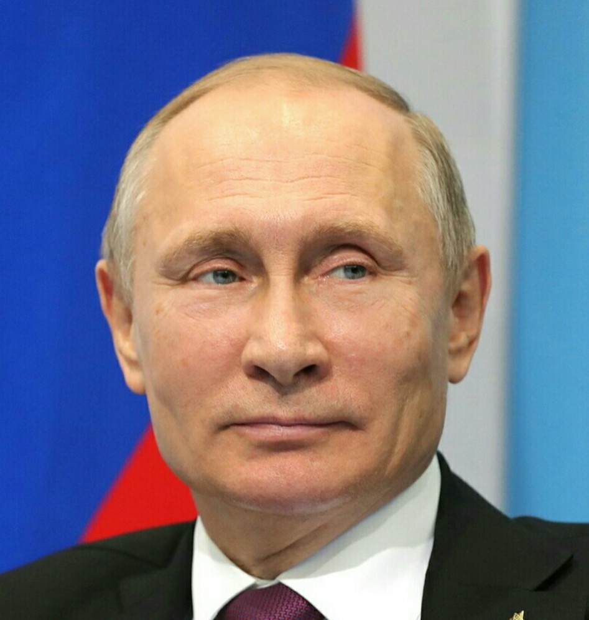 | 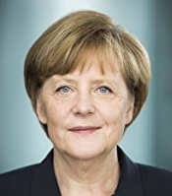 | 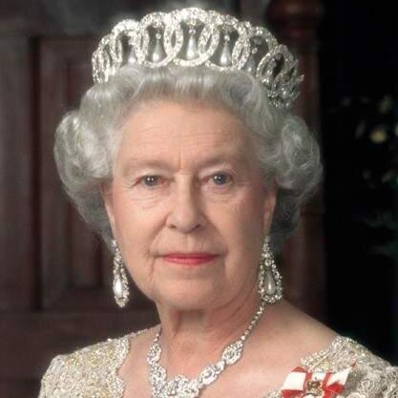

23 | The voters choose the legislators and the voters choose the chief executive. We have a __ __. | Presidential Democracy
24 | Our chief executive is still a legislator. We have a __ ___. | Parliamentary Democracy
25 | When I have all the power to myself, you must do what I say if you want to live in my __. | Autocracy
26 | Republic, presidential democracy, not in European Union. Welcome to __! | Russia
27 | Since the UK was a leading producer of coal, their environment was harmed by air __ from burning so much coal. | Pollution
30 | I grabbed all the power with violence. Be sure to cheer for me in my __ __. | Autocratic dictatorship
31 | The United States uses the dollar. Russia uses the ruble for its __. | currency
32 | The percentage of people who can read at a fourth-grade level is the __ __. | Literacy rate
33 | Constitutional monarchy, parliamentary democracy.. Welcome to the __ __. | United Kingdom
34 | This island nation is far north. Ocean breezes keep the climate of __ __ warm and rainy. | United Kingdom
35 | A total ban on trade to pressure or punish a country is called an __. | embargo
37 | This country has never been interested in joining the European Union: __ | Russia
38 | The skill and health of workers is called __ __. | Human capital
39 | I have a great idea and I start a business.  __ like me help the economy grow. | entrepreneur
40 | The total value of all goods and services produced in one country in one year divided by the population is called the __ __ __ __ __. | Per capita GDP
41 | Around 70% of Europeans follow this religion: | Christianity
42 | There are two names for equipment for business such as roads, factories and ports:  __ __ or __ __ | Physical Capital or capital goods
44 | Gifts from nature that people value are called __ __. We can’t create them, but we can manage them. | Natural resources

